CURRICULUM VITAE

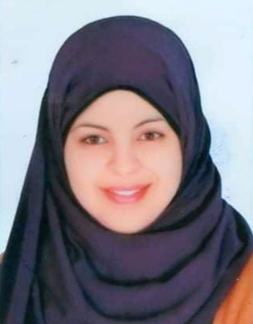

Name : Doaa Hassan Rushdy

Date of Birth : 1/10/1995

Gender : Female

Nationality : Egyptian

Address : Department of Pharmaceutical Analytical Chemistry,
Faculty of Pharmacy, Assiut University, Assiut, Egypt

Mobile : 01091744294

E-mail : doaahassan63@yahoo.com
Moatazali91@yahoo.com
Doaamoataz8895@gmail.com
Doaa_Rushdy@pharm.aun.edu.eg

Languages : Arabic and English

ACADEMIC QUALIFICATIONS
Degrees

Bachelor of Pharmaceutical Sciences in 2018, and demonstrator at Pharmaceutical Analytical Chemistry Department at Faculty of Pharmacy, Assiut University.

Grade

Demonstrator at Pharmaceutical Analytical Chemistry Department at Faculty of Pharmacy, Assiut University ( From January 2020 till now)

COMPUTER SKILLS

Microsoft Office Word, Excel, Power-point, Internet, windows and IT.

